 | Broadrick  Secondary School  2 Dunman Road S439188 Tel:3445025

MATHEMATICS D
Secondary 4 Normal Technical
Special Holiday Homework
April 2003

Name : ________________________
Index Number : ________________________
Class : ________________________

Write your answers and working on the separate answer paper.

electronic calculators or mathematical tables may be used in this paper.

This question paper consists of 3 printed pages including the cover page.

Page 1
2

- In 1992, the population of Singapore was 2 792 000.

(a) Write down this population in words. [1]

(b) Write this population in standard form. [1]

2 (a) Factorise completely 3a² – 6ab [1]

(b) Solve the equation 3(x + 5) – 2(4 – x) = 23 [2]

3 O is the centre of a circle with radius 6 cm A
and angle AOC = 120°. Calculate
(a) the length of the arc ADC, [2] D
6 cm
(b) the area of the sector ABCO. [2] 120° O
B
C
[ Take π to be 3.142 ]

4 Points A, B, C and D lie on level ground. North
The point D is due north of A. D
∠DAC = 130°, ∠CAB = 90°and ∠ABC = 63°.
A
Find the bearing of 130°
(a) B from A, [1]
63° B
(b) C from B. [2]

C

3

The inside radius of a cylindrical pot is 30 cm. It contains water to a depth of 10 cm.

Taking π to be 3.14, calculate

(a) the volume of water in the pot, [2]

(b) the surface area of the wetted part of the pot. [4]

- ABD is a triangle in which ∠ADB = 90°. C is a point on AD. B
AB = 20 cm, AC = 11 cm, and BC = 13 cm.
Calculate 20 cm
- angle ACB, [2]
- the area of triangle ABC, [2] 13 cm
- the length of BD. [2]
A 11 cm C D

( In triangle ABC, c² = a² + b² – 2ab cos C, area of ΔABC = ½ ab sin C )

- The table below shows the heights of 50 pupils surveyed.

Height ( x cm) | 160 ≤ x < 166 | 166≤ x < 172 | 172 ≤ x < 178 | 178 ≤ x < 184
No. of pupils | 8 | 18 | 14 | 10

(a) Calculate the number of pupils who are at least 172 cm in height. [1]

(b) State the modal class. [1]

(c) Calculate the mean height for this distribution, correct to the nearest cm. [4]

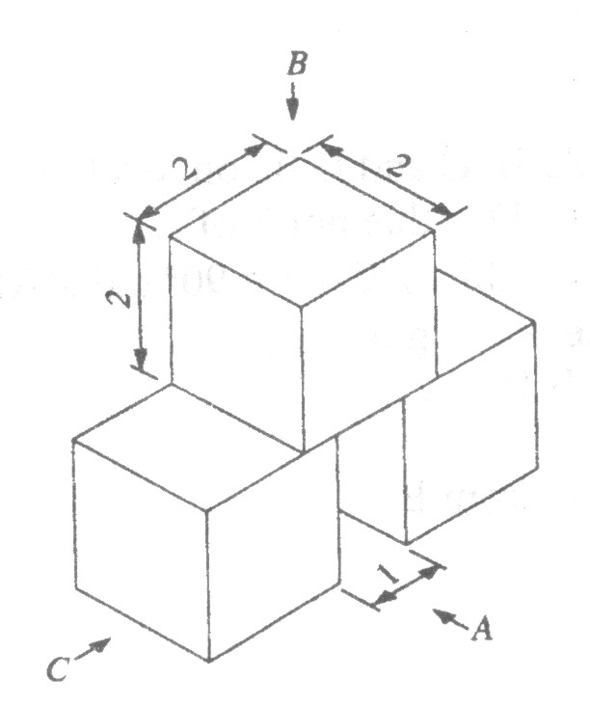
- Three identical cubes of sides 2 cm are
arranged symmetrically in the diagram
shown. There is a 1-cm gap between the
two lower blocks.
Draw full size
- the front elevation as seen from A, [2]
- the plan as seen from B, [2]
- the side elevation as seen from C. [2]

END

