 | Broadrick  Secondary School  2 Dunman Road S439188 Tel:63445025 | Marks

Mathematics D
Secondary Four Express
Mid-Year Examination 2002
Part 2 (Marking Scheme)
1 Hour 15 Minutes

Date : 6th May 2002
Time : 0915 - 1030

Name: ________________________
Index Number: ________________________
Class: ________________________

Instructions to Candidates

- Write your name, index number and class in the spaces above.
- Answer all questions from Section A and one question from Section B.
- Write your answers and working in the writing paper provided.
- All working must be clearly shown.
- Omission of essential working will result in loss of marks.
- electronic calculators or mathematical tables may be used in this paper.

INFORMATION FOR Candidates

- The number of marks is given in brackets [ ] at the end of each question or part question.
- If the degree of accuracy is not specified in the question and if the answer is not exact, the answer should be given to three significant figures. Answers in degrees should be given to one decimal place.
- The total marks for this paper is 50.
Section A (38 marks)
Answer all questions in this section.

- (a) Solve the equation $3x^{2}−5x−5=0$, giving your answers correct to 2 decimal places. x $=\frac{−(−5)±\sqrt{(−5)^{2}−4(3)(−5)}}{2(3)}$ [1]
$=\frac{5±\sqrt{\text{25}+\text{60}}}{6}=\frac{5±\sqrt{\text{85}}}{6}$ [1]
$=\frac{5+\sqrt{\text{85}}}{6}$ or $=\frac{5−\sqrt{\text{85}}}{6}$ $x=2\text{.}\text{37}$ or $x=−0\text{.}\text{70}$ [1]
  - Given that $a=\frac{b+1}{2b−1}$, express b in terms of a.
$a=\frac{b+1}{2b−1}$ $⇒2\text{ab}−a=b+1$ [1]
$⇒2\text{ab}−b=a+1$
$⇒b(2a−1)=a+1$ [1]
$⇒b=\frac{a+1}{2a−1}$ [1]
  - Express $\frac{2}{x+1}+\frac{3}{2x−1}$as a single fraction.
$=\frac{2(2x−1)+3(x+1)}{(x+1)(2x−1)}$ [1]
$=\frac{4x−2+3x+3}{(x+1)(2x−1)}=\frac{7x+1}{(x+1)(2x−1)}$ [1]

- In the diagram, A, B, C and D represent 4 towns, which are joined by straight roads. The distance $\text{AB}=6$km, $\text{CB}=7$km, $\text{CD}=6$km, $∠\text{BAC}={\text{55}}^{∘}$ and $∠\text{ACD}={\text{50}}^{∘}$. Calculate
A
B
C
D
50º
55º
6 km
7 km
6 km

  - $∠\text{ACB}$,
$\frac{\text{sin}∠\text{ACB}}{6}=\frac{\text{sin}{\text{55}}^{∘}}{7}$ [1]
$$\text{sin}∠\text{ACB}=\frac{\text{sin}{\text{55}}^{∘}}{7}×6=0\text{.}\text{702}$$
$∠\text{ACB}=\text{44}\text{.}6^{∘}$ [1]
  - the area of triangle ACB,
$\frac{1}{2}×6×7×\text{sin}({\text{180}}^{∘}−{\text{55}}^{∘}−\text{44}\text{.}{\text{60}}^{∘})$ [1]
$=\frac{1}{2}×6×7×\text{sin}(\text{80}\text{.}{\text{40}}^{∘})=\text{20}\text{.}7$km² [1]
  - the distance BD,
${\text{CD}}^{2}=6^{2}+7^{2}−2×6×7×\text{cos}({\text{50}}^{∘}+\text{44}\text{.}6^{∘})$ [1]
${\text{CD}}^{2}=\text{91}\text{.}\text{74}$ [1]
$\text{CD}=9\text{.}\text{58}$km [1]

- The diagram shows points M and N on the sides of AC and AB of triangle ABC such that $\text{AM}:\text{MC}=\text{BN}:\text{NA}=1:2$. The line MN produced meets the line CB produced at R such that N is the midpoint of MR.
A
C
M
B
R
N

By letting $\overset{\vec{}}{\text{AN}}=a$ and $\overset{\vec{}}{\text{AM}}=b$, express in terms of $a$ and/or $b$,
  - $\overset{\vec{}}{\text{MN}}$, $=\overset{\vec{}}{\text{MA}}+\overset{\vec{}}{\text{AN}}=−b+a=a−b$ [1]
  - $\overset{\vec{}}{\text{BC}}$, $=\overset{\vec{}}{\text{BA}}+\overset{\vec{}}{\text{AC}}=\frac{3}{2}\overset{\vec{}}{\text{NA}}+3\overset{\vec{}}{\text{AM}}$ [1]
$=\frac{3}{2}(−a)+3b=\frac{3}{2}(2b−a)$ [1]
  - $\overset{\vec{}}{\text{RB}}$. $=\overset{\vec{}}{\text{RN}}+\overset{\vec{}}{\text{NB}}=\overset{\vec{}}{\text{NM}}+\frac{1}{2}\overset{\vec{}}{\text{AN}}$ [1]
$=−(a−b)+\frac{1}{2}a=b−\frac{1}{2}a=\frac{1}{2}(2b−a)$ [1]
Hence deduce the ratio of $\text{RB}:\text{BC}$. $\overset{\vec{}}{\text{RB}}=\frac{1}{2}×\frac{2}{3}\overset{\vec{}}{\text{BC}}=\frac{1}{3}\overset{\vec{}}{\text{BC}}$ $∴\text{RB}:\text{BC}=1:3$ [1]

- Answer the whole of this question on a sheet of plain paper.
Construct triangle ABC such that $\text{AB}=\text{10}$cm, $\text{BC}=9$cm and $\text{AC}=6$cm. [1]
  - Measure $∠\text{ABC}$, [1]
  - Construct the locus of points which are 4 cm from A. [1]
  - Construct the locus of points which are equidistant from AB and BC. [2]
  - A point P, inside triangle ABC is 4 cm from A and equidistant from AB and BC. Mark clearly, the point P and measure the length of BP. [2]

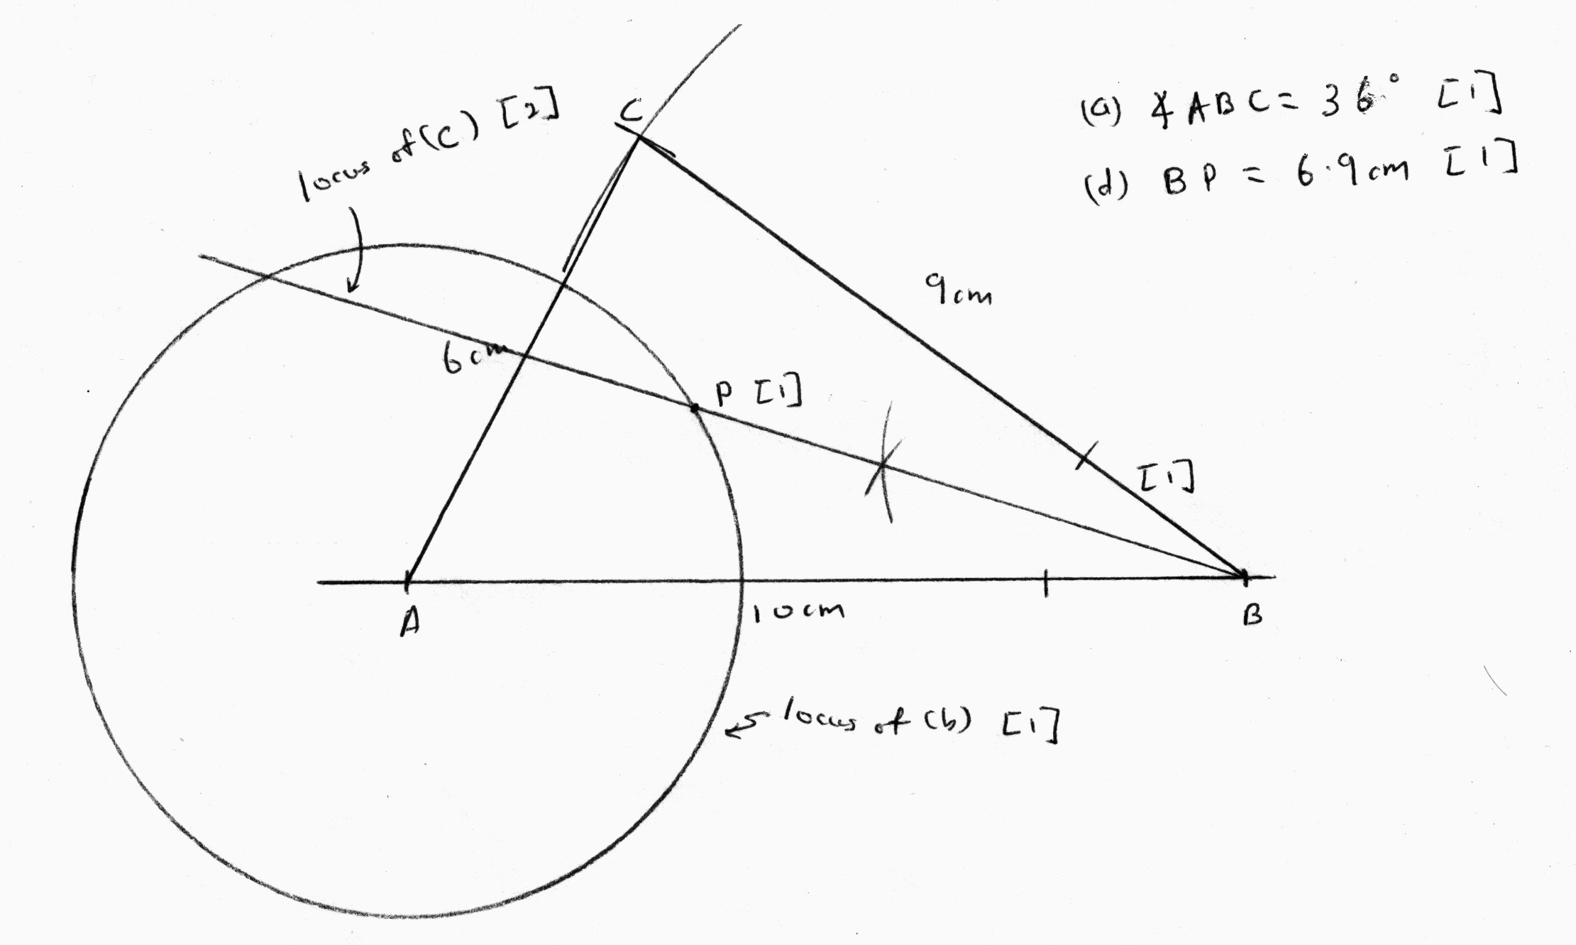

- Answer the whole of this question on a sheet of graph paper.
The following table gives the frequency of marks obtained by 80 candidates in examinations in Mathematics and English.

Marks | $$0<x≤\text{20}$$ | $$\text{20}<x≤\text{40}$$ | $$\text{40}<x≤\text{60}$$ | $$\text{60}<x≤\text{80}$$ | $$\text{80}<x≤\text{100}$$
English | 2 | 10 | 33 | 31 | 4
Mathematics | 8 | 12 | 18 | 25 | 17

  - Copy and complete the following cumulative frequency table for both subjects. [2]
Marks, x |  | 20 | 40 | 60 | 80 | 100
No of candidates obtaining this mark or less | English | 2 | 12 |  |  | 80
No of candidates obtaining this mark or less | Mathematics | 8 | 20 |  |  | 80

  - Using a scale of 2 cm to represent 10 marks on the horizontal axis and 2 cm to represent 10 candidates on the vertical axis, draw in the same graph paper, the cumulative frequency curve for both subjects. [3]

  - Use your graph to estimate,
    - the median marks for English, $=\text{58}$ [1]
    - the interquartile range for Mathematics, $=\text{78}−\text{40}=\text{38}$ [2]
    - how many more candidates achieve distinctions in Mathematics than English, if the minimum mark for achieving a distinction is 75 for both subjects. [2]
$=\text{24}−\text{10}=\text{14}$

Section B (12 marks)
Answer one question in this section.

- (a) An aluminum sheet measures 64 cm by 40 cm. What is the maximum number of 8 cm by 15 cm aluminum pieces that can be cut out?
$\text{64}÷\text{15}=4\text{.}\text{27}$ [1]
$\text{40}÷8=5$ [1]
No of aluminum sheet $=4×5=\text{20}$ [1]

  - Answer the whole of this part on a sheet of graph paper.
Triangle X has vertices $A(1,0)$, $B(0,1)$ and $C(2,2)$
    - Using a scale of 2 cm to represent 1 unit on each axis, draw axes for values of x and y in the ranges $−4≤x≤4$ and $−4≤y≤6$. Draw and label triangle X. [1]
    - A 90º clockwise rotation maps triangle X into triangle Y, which has vertices A', B' and C'. Given that $A'(1,0)$, state the centre of rotation and find the coordinates of B'. Centre $(1,0)$,$B'(2,1)$ [2]
    - A reflection in the line $y=3$ maps triangle X into triangle Z. Draw and label triangle Z. $ΔZ=(1,6),(0,5),(2,4)$ [1]
    - Describe fully, a single transformation that maps triangle Y into triangle Z. [2]
Translation $\left(\begin{matrix}−1 \\ 5\end{matrix}\right)$
    - E is an enlargement with scale factor –2, centre at the origin. S is a shear with shear factor $−2$ in which the y-axis is the invariant line. Draw and label triangle $\text{SE}(X)$. $ΔE(X)=(−2,0),(0,−2),(−4,−4)$ [1]
$Δ\text{SE}(X)=(−2,4),(0,−2),(−4,4)$ [2]

- (a) Given that A is the point $(1,3)$, B is the point $(4,4)$ and C is the point $(5,7)$, find
    - the gradient of AC , $\frac{7−3}{5−1}=\frac{4}{4}=1$ [1]
    - the length of AC, $\sqrt{(7−3)^{2}+(5−1)^{2}}=\sqrt{\text{32}}=5\text{.}\text{66}$ [1]
    - the mid-point of AC, $\left(\frac{1+5}{2},\frac{3+7}{2}\right)=(3,5)$ [1]
    - the coordinates of the point D, such that ABCD is a parallelogram.
Let$D(x,y)$ $\frac{x+4}{2}=3$ $\frac{y+4}{2}=5$ [1]
$x=2$ $y=6$ $D(2,6)$ [1]

  - Answer the whole of this part on a sheet of graph paper.
The variables x and y are connected by the equation $y=1+2^{x}$. The table below shows some corresponding values of x and y.

x | $$−2$$ | $$−1$$ | $$−0\text{.}5$$ | 0 | 0.5 | 1 | 2
y | 1.25 | a | 1.71 | 2 | 2.41 | 3 | 5

    - Calculate the value of a. $a=1\text{.}5$ [1]
    - Taking 4 cm to represent 1 unit on the x-axis and 2 cm to represent 1 unit on the y-axis, draw the graph of $y=1+2^{x}$ for the range of $−2≤x≤2$. [3]
    - Use your graph to solve $2^{x}−3=0$.
$2^{x}−3=0⇒2^{x}=3⇒1+2^{x}=4$ [1]
Plot $y=4$ $∴x=1\text{.}\text{55}$ [1]
    - By drawing a tangent, find the gradient of the curve at the point $(1,3)$.
Gradient $=1\text{.}5$ [2]

End of Paper 2

